PRUEBA SABER 11
PARTE 3

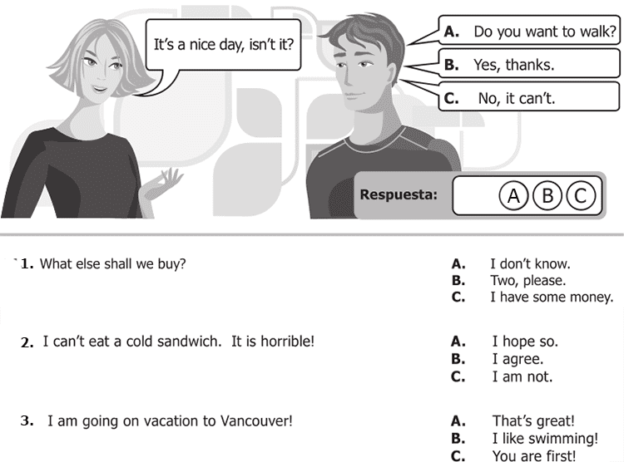
Rta: . A.I don’t know
B.I agree
. A. That’s great!

4 . It rained a lot last night! A. Did you accept?
B. Did you understand?
C. Did you sleep?

5. Grandma, shall I hold those bags for you? A. I'm not afraid!
B. What's the matter?
C. That fine.

6. How much is that umbrella? A. Anything else?
B. 50 dollars.
C. Cash only!

7. Can I use your printer? A. Just a minute
B. Do it this way
C. Think about it

8. Who's the girl? A. She's my sister
B. Yes, she is
C. That's ok

9. Do you know Peter? A. Which?
B. who?
C. What?

10. Can you pass me the salt? A. Here you are
B. I like it
C. It's all right

Continue next page
11.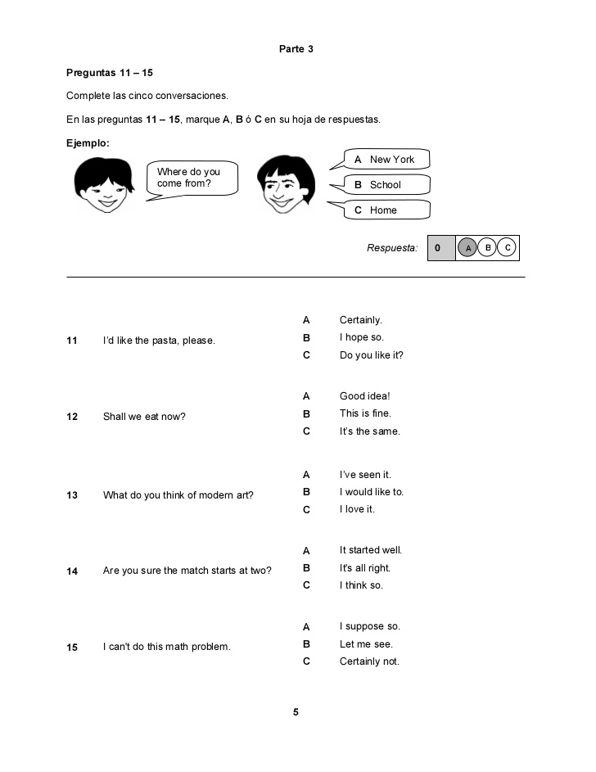11. C.Do you like it? 12. A. Good idea! 13. C.I love it 14. C.I think
15. B.let me see

